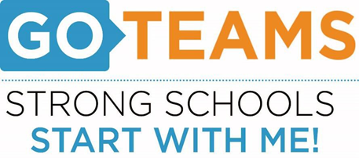

**MEETING NOTICE**

|  |  |  |  |
| --- | --- | --- | --- |
| **School** | **Date** | **Time** | **Location** |
| John Lewis Invictus Academy | Tuesday, August 30,2022 | 5:15 pm | JLIA YouTube Channel |

**Notice Prepared By:** B. Kirkpatrick **Date Posted: 8/24/22**

**Meeting Agenda**

(*agenda may be amended*)

I. Call to Order

II. Roll Call; Establish Quorum

III. Action Items

A. Approval of Agenda

B. Fill Vacant Positions (if applicable)

C. Fill Open Community Member Seat

D. Approval of Previous Minutes

E. Election of Officers

i. Chair

ii. Vice-Chair

iii. Secretary

iv. Cluster Representative

F. Review and Approve Public Comment Protocol

G. Set GO Team Meeting Calendar

H. Review, Confirm/Update, and Adopt GO Team Meeting Norms

IV. Discussion Items (add items as needed)

A. Cell Phone Policy

B. Discussion Item 2:

V. Information Items

A. Principal’s Report

i. Enrollment and/or Leveling Updates

ii. Strategic Plan and Performance Measures Update

B. Information Items

VI. Announcements

A. New GO Team Member Training and Orientation

VIII. Adjournment

*This meeting will not allow for Public Comment*